System : Information System
Company/Office : Kean Gabriel Hotline.
Project Stage : Requirements Specifications and Conceptual Data Model
Date : July 17, 2017
Class & Section : IT-12 MWF, 9:00 – 10:00AM & 1:00-2:00PM
Group Name : trashBin
Group Members : John Mar Lorenzo, Jhon Lloyd Gellica, Marc Andrew Betonio,
Reylar Rebuta

Project Stage : Analysis
Project Title : Requirements Specifications and Conceptual Data Model
Deadline : 17 July 2017

- REQUIREMENTS SPECIFICATION

- Requirements Phase
- Introduction
Being adjudged by the National Children’s Welfare Council as Community of Practice for Children, the City Government pursues its strong commitment to uphold the rights of children by pursuing the establishment of a Child Abuse Hotline. This hotline is a point-to point preselected destination link that automatically connects the caller/victim to the concerned agency and response team dedicated to respond and/or prevent child abuse in the community.

The name of the hotline is in memory of Kean Gabriel, a three (3) year old child residing in Matina Pangi who was a victim of child abuse by his parent and guardian. Sometime in 2016, Kean was beaten, placed in a sack and suspended on a wooden cabinet by his stepfather and fell several times. After falling, the child suffered from hemorrhage which resulted to his instantaneous death. Both his stepfather and mother were thereafter jailed for child abuse.

The hotline is thus established to provide prompt intervention by providing a 24-hour facility for the reporting of all types and forms of child abuse. Same will be launched on October 29, 2016—the 40th day of Kean’s death.

- Current System Overview
System starts with a call from a referral party (e.g. Central 911, Police Station, Radio, GOs/NGOs, Concerned citizens) to Kean Gabriel Hotline. After receiving the call and acquire some information from the referring party, the Kean Gabriel Hotline will request for a Police and Barangay assistance with QRTCC (Quick Response Team for Children’s Concern).

After rescuing the victim, the QRTCC’s workflow follows.

- The walk-in process starts with a referral party and report the incident directly to the QRTCC. After acquiring some information from the referring party, the QRTCC will then send a rescuer together with the help of the Police and barangay officials in the area.

- Identified Risks
- Slow computation of statistics.
- Need to find the records in a logbook.

- User Requirements
- Records data
- User Authentications.
- Statistics.

Nonfunctional Requirements:
- User Friendly
- Reliable
- Usability
- Security

- Specifications Phase

System Overview
- The proposed system for Kean Gabriel Hotline is an Information System which specifically has: Information System for the user not to be hassled with sorting a specific record and can easily record a data for a case, User Authentication because the data of the organization is confidential, and Statistics because the computation for the monthly statistic can take up for about 2 weeks to be done.

Capabilities and Limitations

The Information System’s capabilities are; Records information/data easily and virtually, search specific data without hassle, sorting data by its date, cases, etc., generates monthly and yearly statistics to give report immediately.

The Information System’s limitations are; It cannot delete data since it is not advisable to delete data from the database, it can only search data according to users specified information.

3. Hardware & Software Specification

Processor: AMD Dual Core, Intel Dual Core @ 1.8Ghz or Higher
RAM: 2GB or higher
OS: Windows 7 / 8 / 8.1 (32/64 bit)
Free Disk Space: 50mb

4. User Specification

• Should be Computer literate.

II. CONCEPTUAL DATA MODEL
- Identified User Views

Blank Form
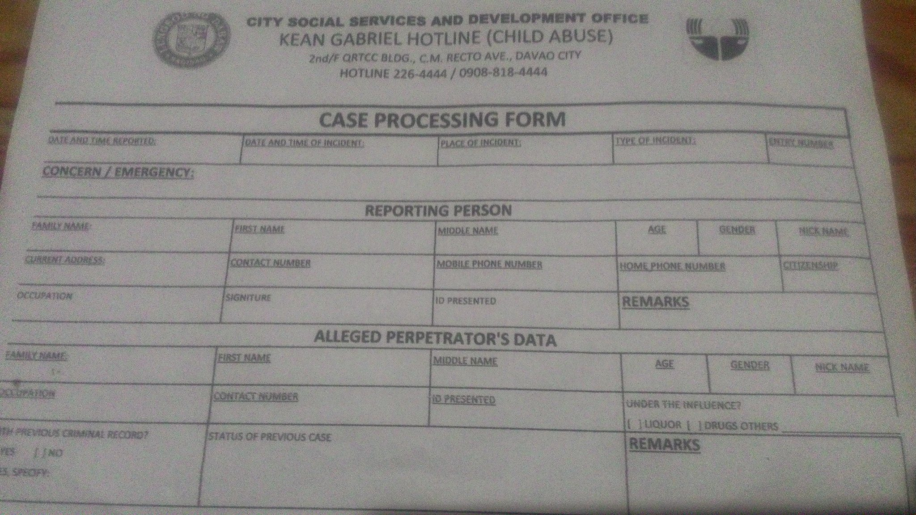

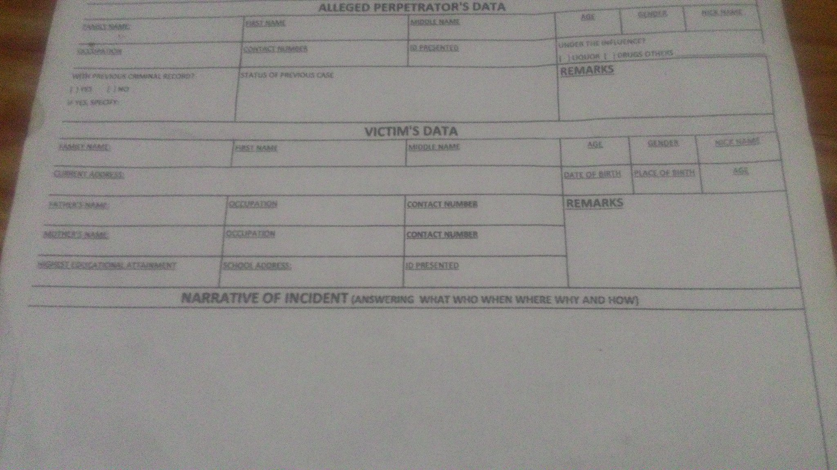

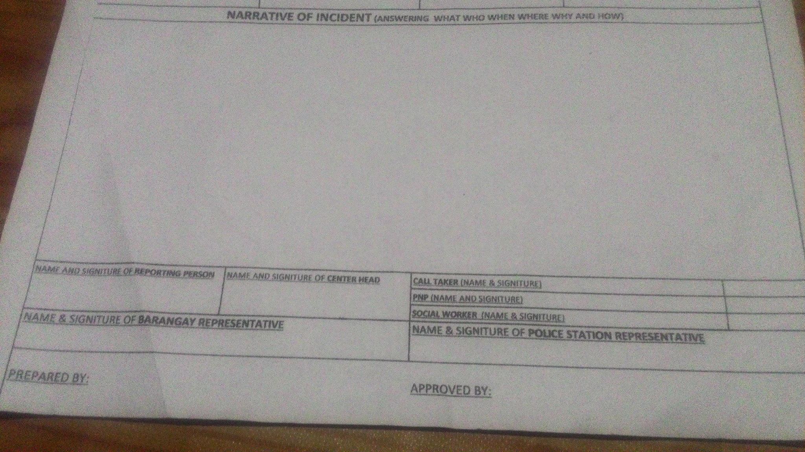

User view summary from interview:

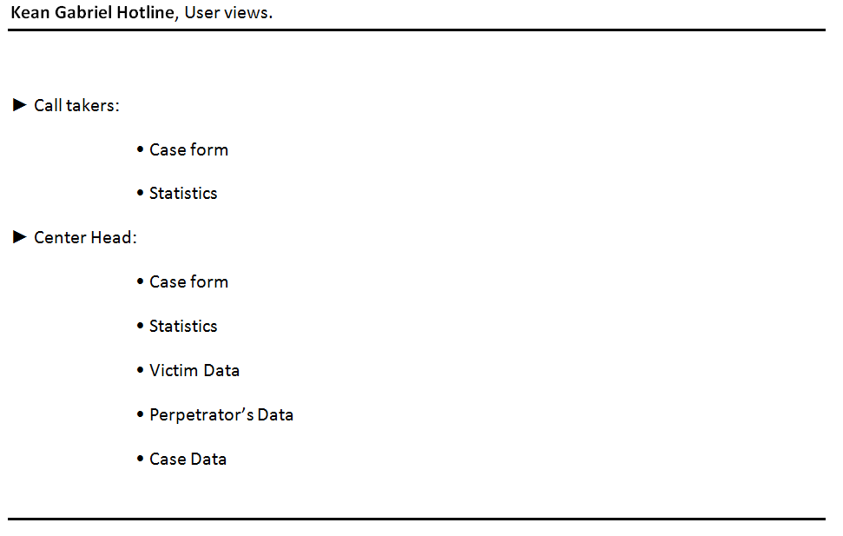

- Conceptual Data Model

1. Person Reporting

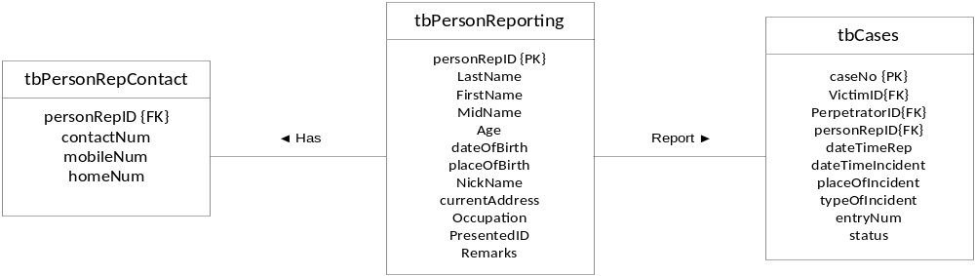

2. Victim

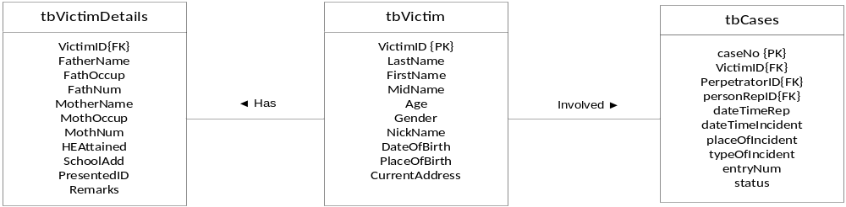

3. Perpetrator

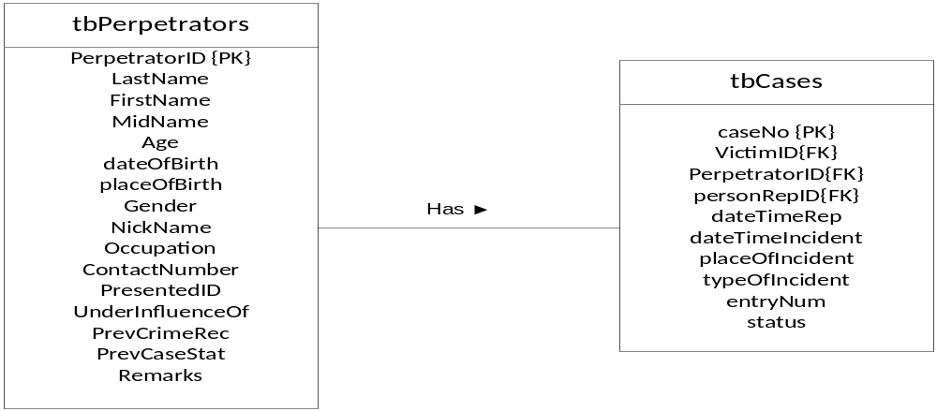

4. Cases
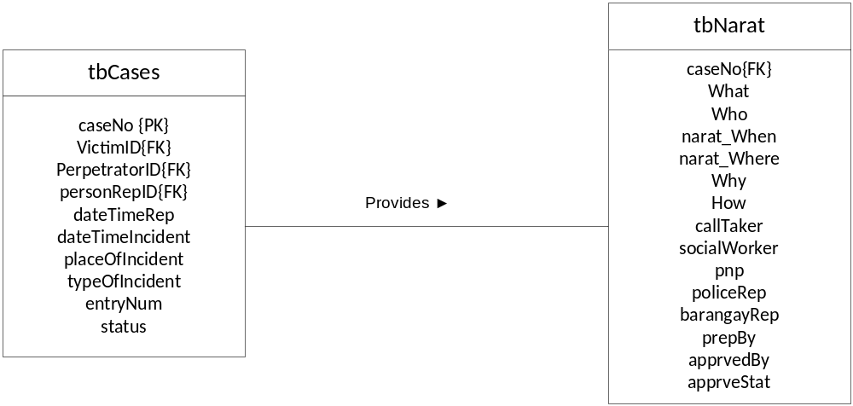

5. Kean Gabriel Hotline’s ERD.

